Creating a first cloud function

1. For creating a cloud function, go to the below link

<https://cloud.google.com/>

below is the screenshot for your reference

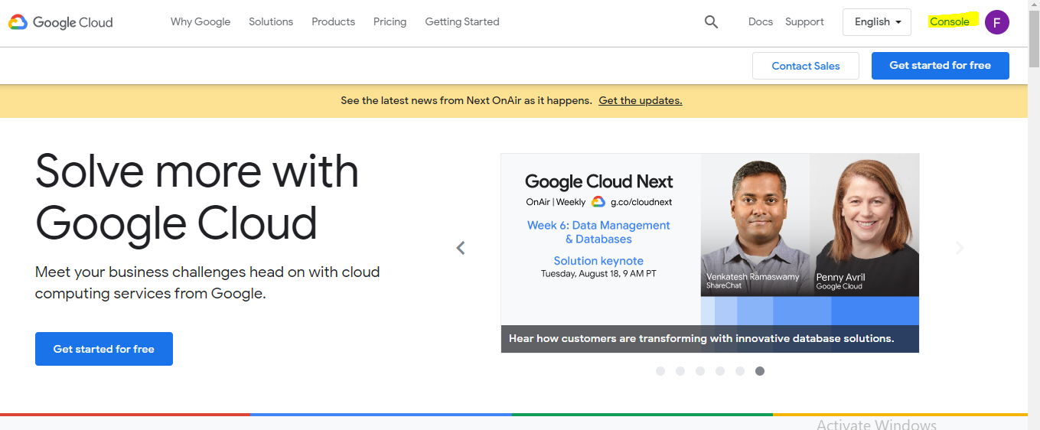

1. Click on console, refer the below screenshot

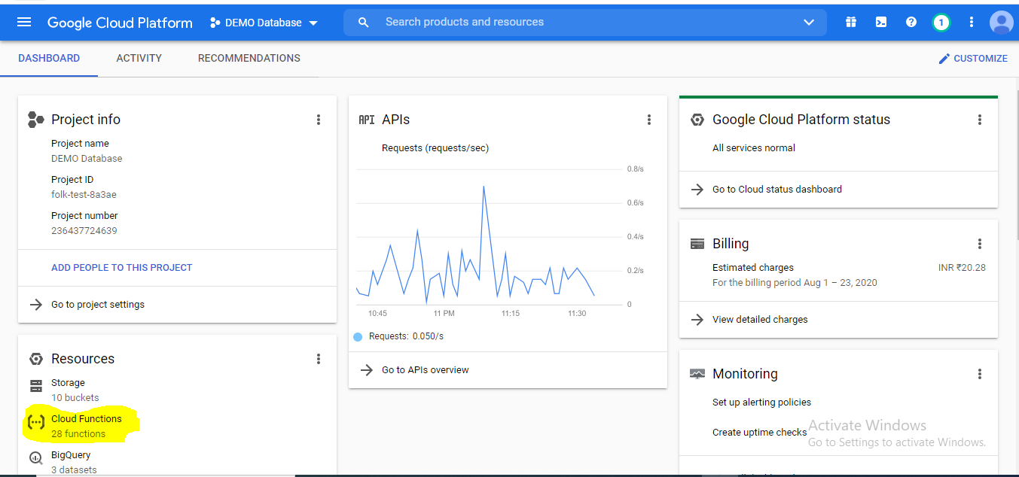

1. Click on cloud functions
2. After that you will screenshot like below

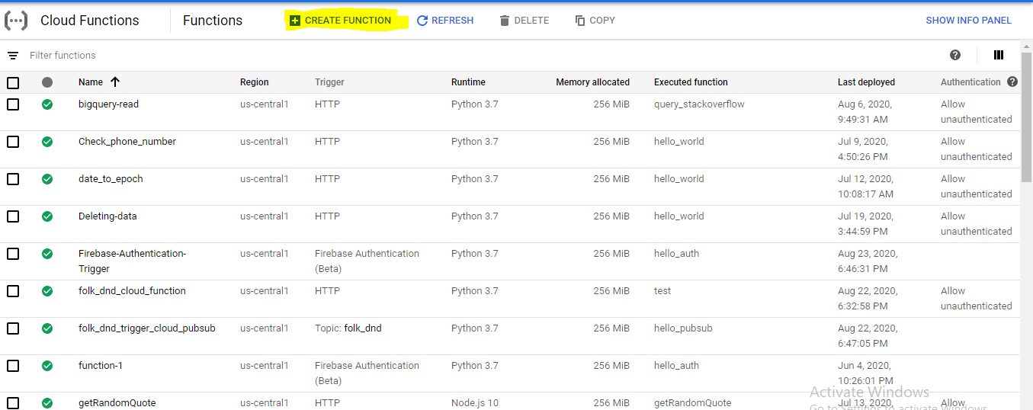

1. Once you click on the “create the function”, you will screen shot like below
2. In the “function name “ place you can give your choice name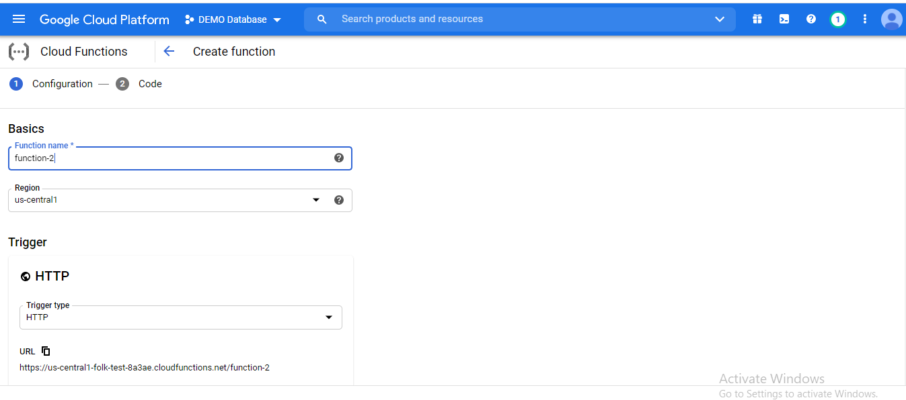
3. After that click on “allow aunthenticated”, go throught the below screenshot

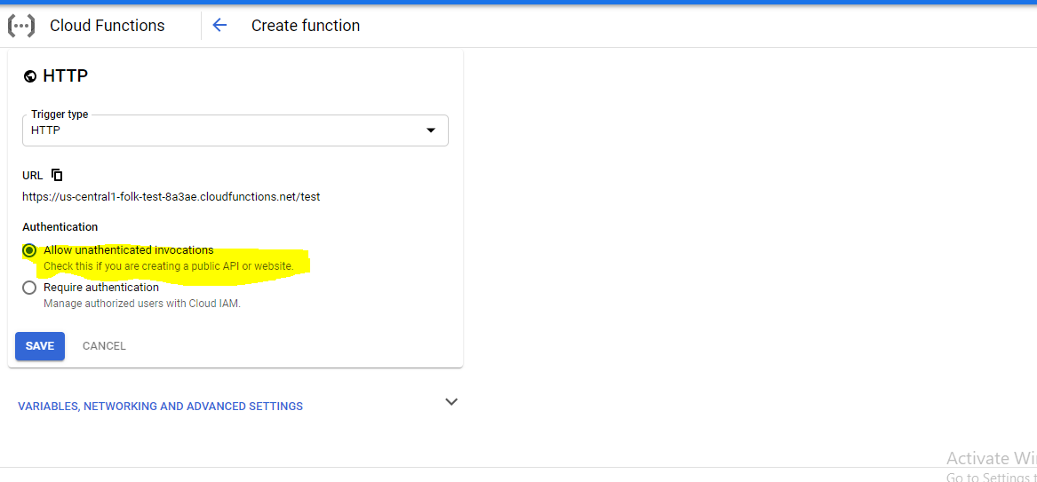

1. After that click on “save”
2. And then click on “next”
3. After that you will screen like below screenshot

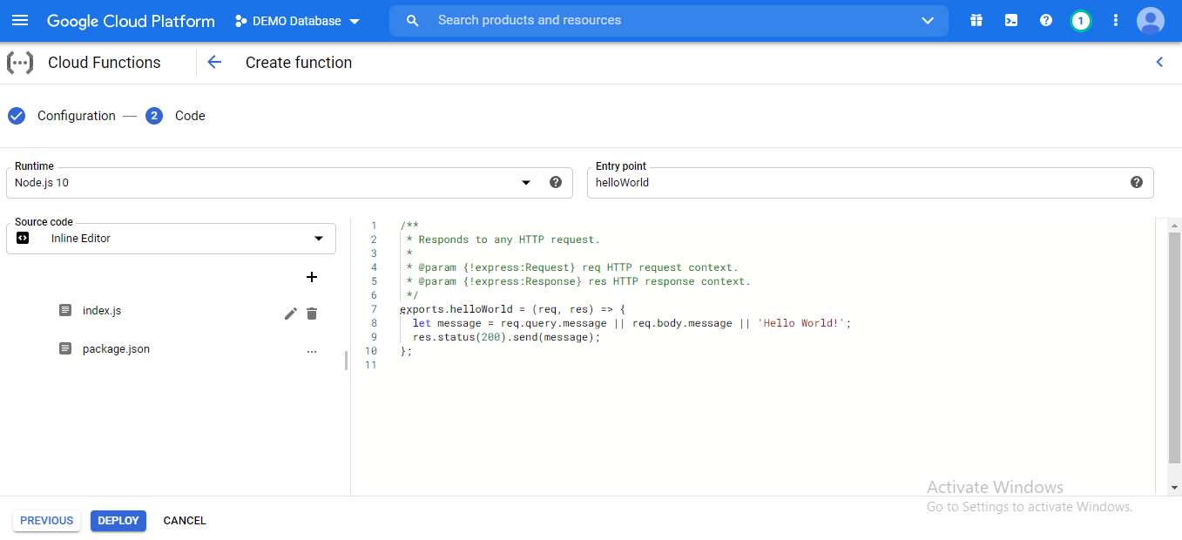

1. In the “run time” it is a drop down box , you can select which language is comfort for you but iam selecting python, below is the screenshot for your reference

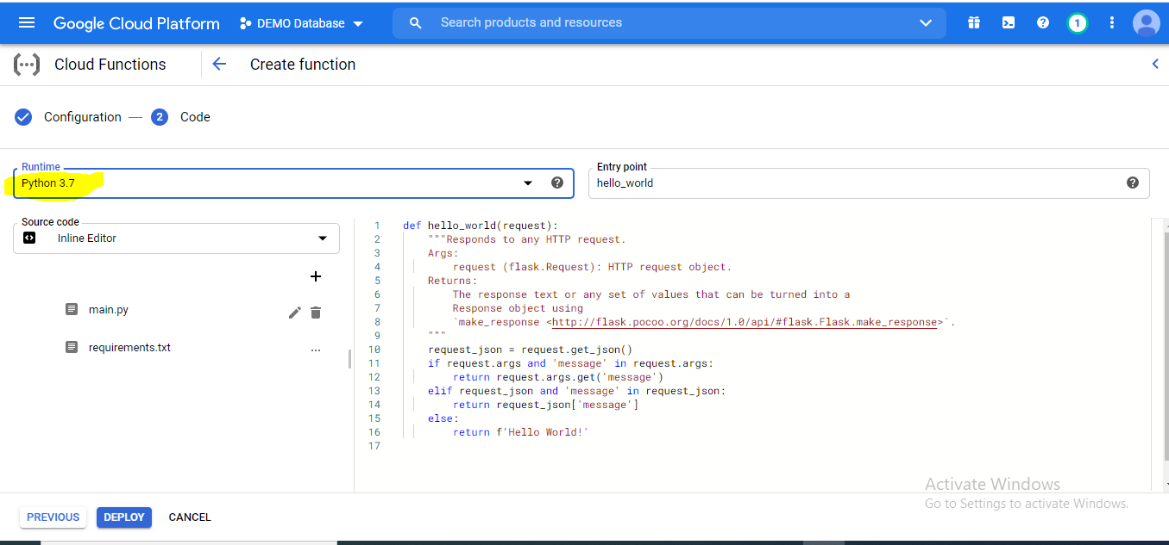

1. In the they are two tabs are there “main.py” and “requirements.txt”
2. In the “main.py” we are writing the our main logic , as of now iam writing the program for inserting data in the document
3. “requiremnts.txt” is to tell the google cloud which package versions we are going to use
4. Note : in the above screenshot there “entrypoint” means which function should execute while running the cloud function so we should mentions same function name there which you are writing original logic
5. In main.py

import firebase_admin

import flask

from firebase_admin import credentials

from firebase_admin import firestore

from flask import jsonify

from datetime import date

from datetime import datetime

from flask import request, jsonify

import urllib.request

import json

import time

import requests

import datetime

import urllib.request

import json

import time

import requests

firebase_admin.initialize_app()

db = firestore.client()

def **hello_world**(request): #here in entry point we should kept “hello world” because our code is written in hello_world”

    data = {

        "name":"test",

        "address":"25/11",

        "number":10,

        "boolean":True

    }

    doc_ref = db.collection(u'test').document()

    doc_ref.set(data)

    print("data is added")

The highlighted code is common for our every cloud function based on requirement if you want you import new packages

In **Requirements.txt**

# Function dependencies, for example:

# package>=version

flask==1.0.2

firebase_admin

12. flask is a function to receive the json data from outside

13. once your function is ready click on deploy, below is the screenshot for your reference.

14. once it successfully deployed , you can click on that cloud functions and click on “testing” , based on your function requirement you have create particulat json data

Below is the screenshot for your reference

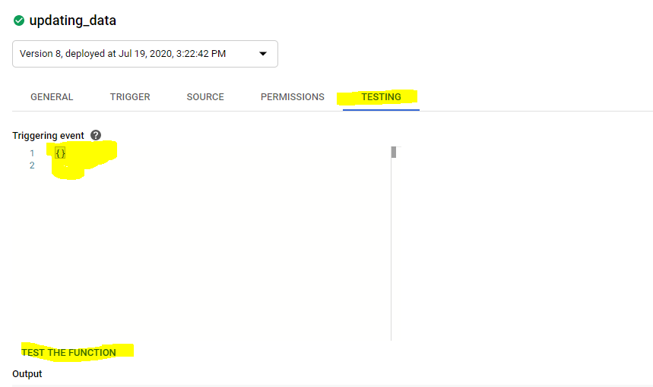

15. the above explaination is the basic google cloud function working , recommend search google and youtube videos